**DAY -1 PROGRAMS**

1.The intervals and corresponding frequencies are as follows. age frequency

1-5. 200

5-15 450

15-20 300

20-50 1500

50-80 700

80-110 44

Compute an approximate median value for the data

INPUT:

#age,frequency

age<-c(5,15,20,50,80,110)

frequency<-c(200,450,800,1500,700,44)

median(age)

median(frequency)

output:

> #age,frequency

> age<-c(5,15,20,50,80,110)

> frequency<-c(200,450,800,1500,700,44)

> median(age)

[1] 35

> median(frequency)

[1] 575

2. .Suppose that the data for analysis includes the attribute age. The age values for the data tuples are (in increasing order) 13, 15, 16, 16, 19, 20, 20, 21, 22, 22, 25, 25, 25, 25, 30, 33, 33, 35, 35, 35, 35, 36, 40, 45, 46, 52, 70.

(a) What is the mean of the data? What is the median?

(b) What is the mode of the data? Comment on the data’s modality (i.e., bimodal, trimodal, etc.).

(c) What is the midrange of the data?

(d) Can you find (roughly) the first quartile (Q1) an

Input:

age <- c(13, 15, 16, 16, 19, 20, 20, 21, 22, 22, 25, 25, 25, 25, 30, 33, 33, 35, 35, 35, 35, 36, 40, 45, 46, 52, 70)

mean_age <- mean(age)

mean_age

median_age <- median(age)

median_age

mode_age <- names(table(age))[which.max(table(age))]

mode_age

range_age <- range(age)

range_age

quartile_25 <- quantile(age, 0.25)

quartile_75 <- quantile(age, 0.75)

quartile_25

quartile_75d the third quartile (Q3) of the data?

Output:

> age <- c(13, 15, 16, 16, 19, 20, 20, 21, 22, 22, 25, 25, 25, 25, 30, 33, 33, 35, 35, 35, 35, 36, 40, 45, 46, 52, 70)

> mean_age <- mean(age)

> mean_age

[1] 29.96296

> median_age <- median(age)

> median_age

[1] 25

> mode_age <- names(table(age))[which.max(table(age))]

> mode_age

[1] "25"

> range_age <- range(age)

> range_age

[1] 13 70

> quartile_25 <- quantile(age, 0.25)

> quartile_75 <- quantile(age, 0.75)

> quartile_25

25%

20.5

> quartile_75

75%

35

3. Data Preprocessing :Reduction and Transformation

Use the two methods below to normalize the following group of data: 200, 300, 400, 600, 1000 (a) min-max normalization by setting min = 0 and max = 1 (b) z-score normalization

Input:

data <- c(200, 300, 400, 600, 1000)

min_max_normalized <- (data - min(data)) / (max(data) - min(data))

min_max_normalized

z_score_normalized <- (data - mean(data)) / sd(data)

z_score_normalized

output:

> data <- c(200, 300, 400, 600, 1000) > min_max_normalized <- (data - min(data)) / (max(data) - min(data)) > min_max_normalized [1] 0.000 0.125 0.250 0.500 1.000 > z_score_normalized <- (data - mean(data)) / sd(data) > z_score_normalized [1] -0.9486833 -0.6324555 -0.3162278 0.3162278 1.5811388

>

4. Data:11,13,13,15,15,16,19,20,20,20,21,21,22,23,24,30,40,45,45,45,71,

72,73,75

a) Smoothing by bin mean

b) Smoothing by bin median

c) Smoothing by bin boundaries

input:

data <- c(11,13,13,15,15,16,19,20,20,20,21,21,22,23,24,30,40,45,45,45,71, 72,73,75)

num_bins <- 5

bin_width <- (max(data) - min(data)) / num_bins

bin_boundaries <- seq(min(data), max(data), by = bin_width)

bin_mean_smoothed <- tapply(data, cut(data, breaks = bin_boundaries), mean)

bin_median_smoothed <- tapply(data, cut(data, breaks = bin_boundaries), median)

bin_boundaries_smoothed <- cut(data, breaks = bin_boundaries)

cat("Bin Mean Smoothing:", bin_mean_smoothed, "\n")

cat("Bin Median Smoothing:", bin_median_smoothed, "\n")

cat("Bin Boundaries Smoothing:", as.numeric(bin_boundaries_smoothed), "\n")

output:

> data <- c(11,13,13,15,15,16,19,20,20,20,21,21,22,23,24,30,40,45,45,45,71, 72,73,75) > num_bins <- 5 > bin_width <- (max(data) - min(data)) / num_bins > bin_boundaries <- seq(min(data), max(data), by = bin_width)

> bin_mean_smoothed <- tapply(data, cut(data, breaks = bin_boundaries), mean) > bin_median_smoothed <- tapply(data, cut(data, breaks = bin_boundaries), median) > bin_boundaries_smoothed <- cut(data, breaks = bin_boundaries) > cat("Bin Mean Smoothing:", bin_mean_smoothed, "\n") Bin Mean Smoothing: 18.30769 27 43.75 NA 72.75 > cat("Bin Median Smoothing:", bin_median_smoothed, "\n") Bin Median Smoothing: 20 27 45 NA 72.5 > cat("Bin Boundaries Smoothing:", as.numeric(bin_boundaries_smoothed), "\n") Bin Boundaries Smoothing: NA 1 1 1 1 1 1 1 1 1 1 1 1 1 2 2 3 3 3 3 5 5 5 5

>

5. Suppose that a hospital tested the age and body fat data for 18 randomly selected adults with the following results:

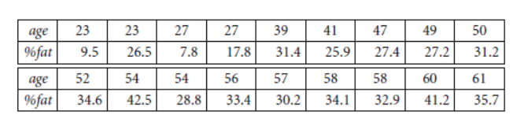

(a) Calculate the mean, median, and standard deviation of age and %fat. (b) Draw the boxplots for age and %fat. (c) Draw a scatter plot and a q-q plot based on these two variables.

Input:

age<-c(23,23,27,27,39,41,47,49,50,52,54,54,56,57,58,58,60,61)

fat<-c(9.5,26.5,7.8,17.8,31.4,25.9,27.4,27.2,31.2,34.6,42.5,28.8,33.4,30.2,34.1,32.9,41.2,35.7)

mean(age)

median(age)

sd(age)

mean(fat)

median(fat)

sd(fat)

#boxplot

boxplot(age,fat)

#scatter plot

scatter.smooth(age,fat)

#qplot

qqplot(age,fat)

output:

> age<-c(23,23,27,27,39,41,47,49,50,52,54,54,56,57,58,58,60,61)

> fat<-c(9.5,26.5,7.8,17.8,31.4,25.9,27.4,27.2,31.2,34.6,42.5,28.8,33.4,30.2,34.1,32.9,41.2,35.7)

> mean(age)

[1] 46.44444

> median(age)

[1] 51

> sd(age)

[1] 13.21862

> mean(fat)

[1] 28.78333

> median(fat)

[1] 30.7

> sd(fat)

[1] 9.254395

> #boxplot

> boxplot(age,fat)

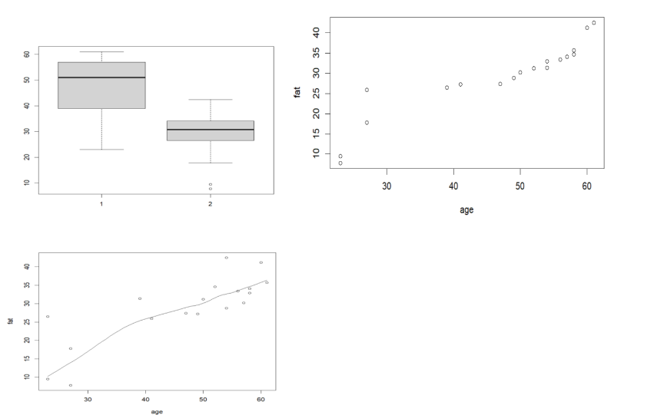

6. Suppose that a hospital tested the age and body fat data for 18 randomly selected adults with the following results:

(i) Use min-max normalization to transform the value 35 for age onto the range [0.0, 1.0]. (ii) Use z-score normalization to transform the value 35 for age, where the standard deviation of age is 12.94 years. (iii) Use normalization by decimal scaling to transform the value 35 for age. Perform the above functions using R – tool

Input:v<-c(23,23,27,27,39,41,47,49,50,52,54,54,56,57,58,58,60,61)

min<-0

max<-1

#min_max

min_max=((35-min(v))/(max(v)-min(v)))

print(min_max)

#z-score

m=mean(v)

s<-12.94

z_score=(35-m)/s

print(z_score)

#decimal scaling

m<-35

j=max(m)<1

decimal_scaling=m/10^j

print(decimal_scaling)

Output:

> v<-c(23,23,27,27,39,41,47,49,50,52,54,54,56,57,58,58,60,61)

> min<-0

> max<-1

> #min_max

> min_max=((35-min(v))/(max(v)-min(v)))

> print(min_max)

[1] 0.3157895

> #z-score

> m=mean(v)

> s<-12.94

> z_score=(35-m)/s

> print(z_score)

[1] -0.8844238

> #decimal scaling

> m<-35

> j=max(m)<1

> decimal_scaling=m/10^j

> print(decimal_scaling)

[1] 35

7.The following values are the number of pencils available in the different boxes. Create a vector and find out the mean, median and mode values of set of pencils in the given data.

Box1 Box2 Box3 Box4 Box5 Box6 Box7 Box8 Box9 Box 10

9 25 23 12 11 6 7 8 9 10

Input:

pencils<-c(9,25,23,12,11,6,7,8,9,10)

mean(pencils)

median(pencils)

mode=names(table(pencils))[table(pencils)==max(table(pencils))]

mode

Output:

> pencils<-c(9,25,23,12,11,6,7,8,9,10)

> mean(pencils)

[1] 12

> median(pencils)

[1] 9.5

> mode=names(table(pencils))[table(pencils)==max(table(pencils))]

> mode

[1] "9"

8. the following table would be plotted as (x,y) points, with the first column being the x values as number of mobile phones sold and the second column being the y values as money. To use the scatter plot for how many mobile phones sold.

x :4 1 5 7 10 2 50 25 90 36

y :12 5 13 19 31 7 153 72 275 110

input:

#scatterplot

x<-c(4,1,5,7,10,2,50,25,90,36)

y<-c(12,5,13,19,31,7,153,72,275,110)

scatter.smooth(x,y)

output:

> #scatterplot > x<-c(4,1,5,7,10,2,50,25,90,36) > y<-c(12,5,13,19,31,7,153,72,275,110) > scatter.smooth(x,y)

>

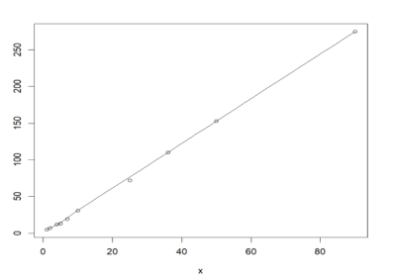

9. Implement of the R script using marks scored by a student in his model exam has been sorted as follows: 55, 60, 71, 63, 55, 65, 50, 55,58,59,61,63,65,67,71,72,75. Partition them into three bins by each of the following methods. Plot the data points using histogram.

(a) equal-frequency (equi-depth) partitioning (b) equal-width partitioning

Input:

marks <- c(55, 60, 71, 63, 55, 65, 50, 55, 58, 59, 61, 63, 65, 67, 71, 72, 75)

bin_size <- length(marks) / 3

bin_size <- ceiling(bin_size)

bins_equal_frequency <- cut(marks, breaks = c(-Inf, quantile(marks, probs = seq(0, 1, 1/3)), Inf), labels = FALSE)

hist(marks, breaks = c(quantile(marks, probs = seq(0, 1, 1/3)), Inf), main = "Histogram with Equal-Frequency Partitioning", xlab = "Marks", ylab = "Frequency", col = "skyblue", border = "black")

bin_width <- (max(marks) - min(marks)) / 3

breaks_equal_width <- seq(min(marks), max(marks) + bin_width, by = bin_width)

bins_equal_width <- cut(marks, breaks = breaks_equal_width, labels = FALSE)

hist(marks, breaks = breaks_equal_width, main = "Histogram with Equal-Width Partitioning", xlab = "Marks", ylab = "Frequency", col = "lightgreen", border = "black")

Output:

> marks <- c(55, 60, 71, 63, 55, 65, 50, 55, 58, 59, 61, 63, 65, 67, 71, 72, 75)

> bin_size <- length(marks) / 3

> bin_size <- ceiling(bin_size)

> bins_equal_frequency <- cut(marks, breaks = c(-Inf, quantile(marks, probs = seq(0, 1, 1/3)), Inf), labels = FALSE)

> hist(marks, breaks = c(quantile(marks, probs = seq(0, 1, 1/3)), Inf), main = "Histogram with Equal-Frequency Partitioning", xlab = "Marks", ylab = "Frequency", col = "skyblue", border = "black")

10. Suppose that the speed car is mentioned in different driving style.

Regular 78.3 81.8 82 74.2 83.4 84.5 82.9 77.5 80.9 70.6 Speed

Calculate the Inter quantile and standard deviation of the given data.

Input:

#IQR, SD

v<-c(78.3,81.8,82,74.2,83.4,84.5,82.9,77.5,80.9,70.6)

IQR(v)

sd(v)

Output:

> v<-c(78.3,81.8,82,74.2,83.4,84.5,82.9,77.5,80.9,70.6) > IQR(v) [1] 4.975 > sd(v) [1] 4.445835

>

11.Suppose that the data for analysis includes the attribute age. The age values for the data tuples are (in increasing order) 13, 15, 16, 16, 19, 20, 20, 21, 22, 22, 25, 25, 25, 25, 30, 33, 33, 35, 35, 35, 35, 36, 40, 45, 46, 52, 70.

Can you find (roughly) the first quartile (Q1) and the third quartile (Q3) of the data?

Input:

#Q1, Q2

age<-c(13,15,16,16,19,20,20,21,22,22,25,25,25,25,30,33,33,35,35,35,35,36,40,45,46,52,70)

quantile(age,.25)

quantile(age,.75)

Output:

> #Q1, Q2

> age<-c(13,15,16,16,19,20,20,21,22,22,25,25,25,25,30,33,33,35,35,35,35,36,40,45,46,52,70)

> quantile(age,.25)

25%

20.5

> quantile(age,.75)

75%

35

**DAY-2 PROGRAMS**

1.Covariance and correlation

Children of three ages are asked to indicate their preference for three photographs of adults. Do the data suggest that there is a significant relationship between age and photograph preference? What is wrong with this study?

Photograph:

Age of child A B C

5-6 years: 18 22 20

7-8 years: 2 28 40

9-10 years: 20 10 40

1. Use cov() to calculate the sample covariance between B and C.

2. Use another call to cov() to calculate the sample covariance matrix for the preferences.

3. Use cor() to calculate the sample correlation between B and C.

4. Use another call to cor() to calculate the sample correlation matrix for the preferences.

Input:

data <- data.frame(

Age = rep(c("5-6 years", "7-8 years", "9-10 years"), each = 3),

A = c(18, 2, 20, 22, 28, 10, 20, 40, 40),

B = c(22, 28, 10, 20, 40, 40, 30, 45, 50),

C = c(20, 40, 40, 30, 45, 50, 15, 35, 25)

)

covariance_BC <- cov(data$B, data$C)

cat("Covariance between B and C:", covariance_BC, "\n")

covariance_matrix <- cov(data[, c("A", "B", "C")])

cat("Covariance matrix:\n", covariance_matrix, "\n")

correlation_BC <- cor(data$B, data$C)

cat("Correlation between B and C:", correlation_BC, "\n")

correlation_matrix <- cor(data[, c("A", "B", "C")])

cat("Correlation matrix:\n", correlation_matrix, "\n")

output:

> data <- data.frame(

+ Age = rep(c("5-6 years", "7-8 years", "9-10 years"), each = 3),

+ A = c(18, 2, 20, 22, 28, 10, 20, 40, 40),

+ B = c(22, 28, 10, 20, 40, 40, 30, 45, 50),

+ C = c(20, 40, 40, 30, 45, 50, 15, 35, 25)

+ )

> covariance_BC <- cov(data$B, data$C)

> cat("Covariance between B and C:", covariance_BC, "\n")

Covariance between B and C: 16.875

> covariance_matrix <- cov(data[, c("A", "B", "C")])

> cat("Covariance matrix:\n", covariance_matrix, "\n")

Covariance matrix:

156.4444 84.83333 -38.33333 84.83333 171 16.875 -38.33333 16.875 137.5

> correlation_BC <- cor(data$B, data$C)

> cat("Correlation between B and C:", correlation_BC, "\n")

Correlation between B and C: 0.1100511

> correlation_matrix <- cor(data[, c("A", "B", "C")])

> cat("Correlation matrix:\n", correlation_matrix, "\n")

Correlation matrix:

1 0.5186667 -0.2613636 0.5186667 1 0.1100511 -0.2613636 0.1100511 1

2.Imagine that you have selected data from the All Electronics data warehouse for analysis. The data set will be huge! The following data are a list of All Electronics prices for commonly sold items (rounded to the nearest dollar). The numbers have been sorted: 1, 1, 5, 5, 5, 5, 5, 8, 8, 10, 10, 10, 10, 12, 14, 14, 14, 15, 15, 15, 15, 15, 15, 18, 18, 18, 18, 18,

Input:

# Given data

prices <- c(1, 1, 5, 5, 5, 5, 5, 8, 8, 10, 10, 10, 10, 12, 14, 14, 14, 15, 15, 15, 15, 15, 15, 18, 18, 18, 18, 18, 18, 18, 18, 20, 20, 20, 20, 20, 20, 20, 21, 21, 21, 21, 25, 25, 25, 25, 25, 28, 28, 30, 30, 30)

# (i) Equal-frequency partitioning with bin equal to 3

equal_freq_bins <- cut(prices, breaks = 3, labels = FALSE)

cat("(i) Equal-frequency partitioning bins:\n", equal_freq_bins, "\n")

18, 18, 18, 20, 20, 20, 20, 20, 20, 20, 21, 21, 21, 21, 25, 25, 25, 25, 25, 28, 28, 30,

30, 30.

(i) Partition the dataset using an equal-frequency partitioning method with bin equal to 3 (ii) apply data

smoothing using bin means and bin boundary.

(iii) Plot Histogram for the above frequency division

# (ii) Data smoothing using bin means and bin boundary

bin_means <- tapply(prices, equal_freq_bins, mean)

bin_boundaries <- unique(cut(prices, breaks = 3, labels = FALSE, include.lowest = TRUE))

cat("(ii) Bin Means:\n", bin_means, "\n")

cat("Bin Boundaries:\n", bin_boundaries, "\n")

# (iii) Plot Histogram

hist(prices, breaks = 3, main = "Histogram with Equal-frequency Partitioning", xlab = "Prices", col = "lightblue", border = "black")

output:

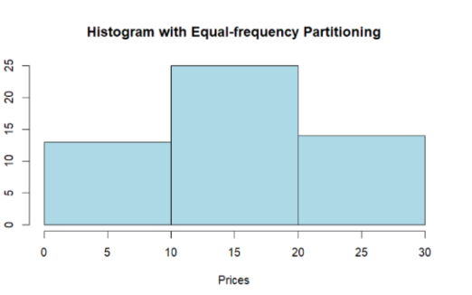

3.Two Maths teachers are comparing how their Year 9 classes performed in the end of year exams. Their results are as follows: Class A: 76, 35, 47, 64, 95, 66, 89, 36, 8476,35,47,64,95,66,89,36,84

Class B: 51, 56, 84, 60, 59, 70, 63, 66, 5051,56,84,60,59,70,63,66,50

(i) Find which class had scored higher mean, median and range. (ii) Plot above in boxplot and give the inferences

Class B: 51, 56, 84, 60, 59, 70, 63, 66, 5051,56,84,60,59,70,63,66,50

Input:

classA <- c(76, 35, 47, 64, 95, 66, 89, 36, 84)

classB <- c(51, 56, 84, 60, 59, 70, 63, 66, 50)

meanA <- mean(classA)

meanB <- mean(classB)

medianA <- median(classA)

medianB <- median(classB)

rangeA <- range(classA)

rangeB <- range(classB)

cat("(i) Class A vs Class B:\n")

cat("Mean: Class A -", meanA, " Class B -", meanB, "\n")

cat("Median: Class A -", medianA, " Class B -", medianB, "\n")

cat("Range: Class A -", diff(rangeA), " Class B -", diff(rangeB), "\n")

boxplot(classA, classB, names = c("Class A", "Class B"), col = c("lightblue", "lightgreen"), main = "Boxplot - Class A vs Class B", ylab = "Scores")

cat("(ii) Inferences from Boxplot:\n")

cat(" - Class A has a wider range of scores compared to Class B.\n")

cat(" - The median score for Class A is higher than that for Class B.\n")

cat(" - Class A has an outlier which affects the mean.\n")

output:

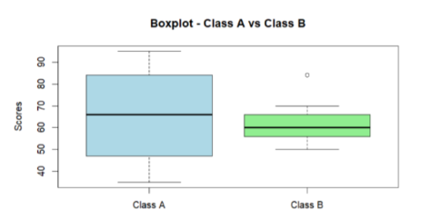

4.Let us consider one example to make the calculation method clear. Assume that the minimum and maximum values for the feature F are $50,000 and $100,000 correspondingly. It needs to range F from 0 to 1. In accordance with min-max normalization, v = $80,

b) Use the two methods below to normalize the following group of data: 200, 300, 400, 600, 1000

(a) min-max normalization by setting min = 0 and max = 1

(b) z-score normalization

Input:

data <- c(200, 300, 400, 600, 1000)

min_max_custom <- function(x, min_val, max_val) {

return (x - min_val) / (max_val - min_val)

}

min_max_normalized_custom <- min_max_custom(data, 200, 1000)

min_max_normalized_default <- scale(data, center = min(data), scale = diff(range(data)))

z_score_normalized <- scale(data)

cat("Original Data: ", data, "\n\n")

cat("(a) Min-Max normalization with custom min and max values:\n")

cat("Normalized Data: ", min_max_normalized_custom, "\n\n")

cat("(b) Min-Max normalization with min = 0 and max = 1:\n")

cat("Normalized Data: ", min_max_normalized_default, "\n\n")

cat("(c) Z-score normalization:\n")

cat("Normalized Data: ", z_score_normalized, "\n")

output:

Original Data: 200 300 400 600 1000

> cat("(a) Min-Max normalization with custom min and max values:\n")

(a) Min-Max normalization with custom min and max values:

> cat("Normalized Data: ", min_max_normalized_custom, "\n\n")

Normalized Data: 0 100 200 400 800

> cat("(b) Min-Max normalization with min = 0 and max = 1:\n")

(b) Min-Max normalization with min = 0 and max = 1:

> cat("Normalized Data: ", min_max_normalized_default, "\n\n")

Normalized Data: 0 0.125 0.25 0.5 1

> cat("(c) Z-score normalization:\n")

(c) Z-score normalization:

> cat("Normalized Data: ", z_score_normalized, "\n")

Normalized Data: -0.9486833 -0.6324555 -0.3162278 0.3162278 1.581139

5.Make a histogram for the “AirPassengers “dataset, start at 100 on the x-axis, and from values 200 to 700, make the bins 150 wide

Input:

data("AirPassengers")

start_value <- 100

bin_width <- 150

bin_breaks <- seq(start_value, 700, by = bin_width)

hist(AirPassengers, breaks = bin_breaks, xlim = c(start_value, max(bin_breaks) + bin_width),

main = "Histogram for AirPassengers Dataset",

xlab = "Passenger Count", ylab = "Frequency", col = "skyblue", border = "black")

legend("topright", legend = c("Passenger Count"), fill = c("skyblue"))

output:

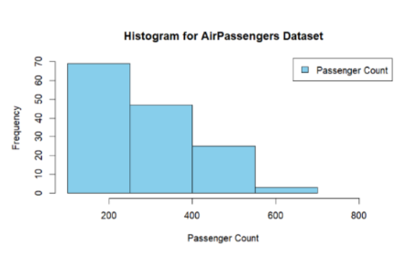

6.Obtain Multiple Lines in Line Chart using a single Plot Function in R.Use attributes“mpg”and“qsec”of the dataset “mtcars”

Input:

data(mtcars)

plot(mtcars$mpg, type = "l", col = "blue", xlab = "Car Index", ylab = "Miles Per Gallon", main = "Multiple Lines Chart - mpg and qsec")

lines(mtcars$qsec, col = "red")

legend("topright", legend = c("mpg", "qsec"), col = c("blue", "red"), lty = 1)

output:

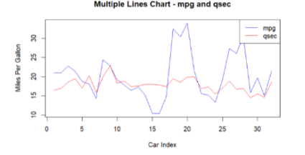

7.Download the Dataset "water" From R dataset Link.Find out whether there is a linear relation between attributes"mortality" and"hardness" by plot function.Fit the Data into the Linear Regression model.Predict the mortality for the hardness=88.

Input:

data(mtcars)

mortality <- mtcars$mpg

hardness <- mtcars$hp

plot(hardness, mortality, main = "Linear Regression: Mortality vs. Hardness",

xlab = "Hardness", ylab = "Mortality", pch = 16, col = "blue")

linear_model <- lm(mortality ~ hardness)

abline(linear_model, col = "red")

new_data <- data.frame(hardness = 88)

predicted_mortality <- predict(linear_model, newdata = new_data)

cat("Predicted Mortality for Hardness=88:", predicted_mortality, "

output:

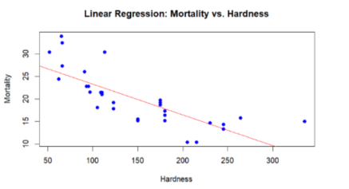

8.Create a Boxplot graph for the relation between "mpg"(miles per galloon) and "cyl"(number of Cylinders) for the dataset "mtcars" available in R Environment.

Input:

data(mtcars)

boxplot(mpg ~ cyl, data = mtcars, main = "Boxplot: mpg vs. cyl",

xlab = "Number of Cylinders", ylab = "Miles Per Gallon", col = "skyblue")

output:

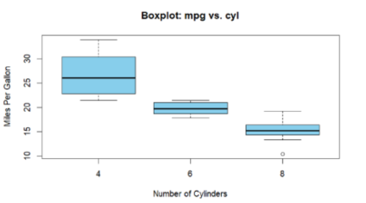

9. Assume the Tennis coach wants to determine if any of his team players are scoring

outliers. To visualize the distribution of points scored by his players, then how can he

decide to develop the box plot? Give suitable example using Boxplot visualization

technique.

Input:

points_scored <- c(35, 42, 48, 52, 56, 60, 62, 65, 68, 72, 76, 80, 85, 88, 92, 100, 110)

boxplot(points_scored, main = "Boxplot: Points Scored by Tennis Players",

xlab = "Players", ylab = "Points Scored", col = "lightblue", border = "black")

Output:

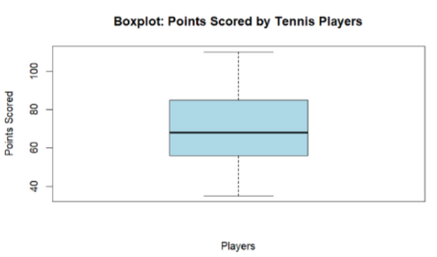

10. Implement using R language in which age group of people are affected byblood pressure based on the diabetes dataset show it using scatterplot and bar chart (that is BloodPressure vs Age using dataset “diabetes.csv”)

INPUT:

data <- data.frame(

Age = c(25, 30, 35, 40, 45, 50, 55, 60, 65, 70),

BloodPressure = c(120, 130, 140, 150, 135, 145, 155, 160, 150, 140)

)

plot(data$Age, data$BloodPressure, main = "Blood Pressure vs Age", xlab = "Age", ylab = "Blood Pressure", pch = 16, col = "blue")

barplot(data$BloodPressure, names.arg = data$Age, main = "Blood Pressure vs Age", xlab = "Age", ylab = "Blood Pressure", col = "green", border = "black")

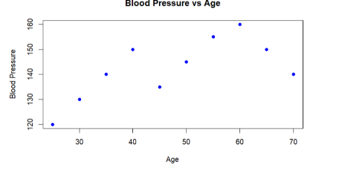

**DAY-03**

1.Consider the data set and perform the Apriori Algorithm and FP algorithm support:3 and confidence=50%

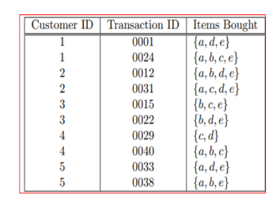

INPUT:

@relation dataset

@attribute a{true,false}

@attribute b{true,false}

@attribute c{true,false}

@attribute d{true,false}

@attribute e{true,false}

@data

true false false true true

true true true false true

true true false true true

true false true true true

false true true false true

false true false true true

false false true true false

true true true false false

true true false false true

true true false false true

ouput:

FP GROWTH

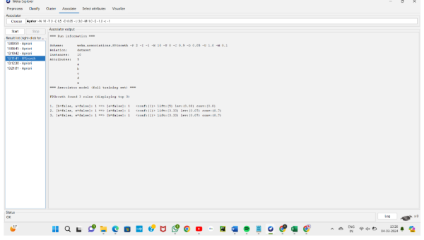

Appriori:

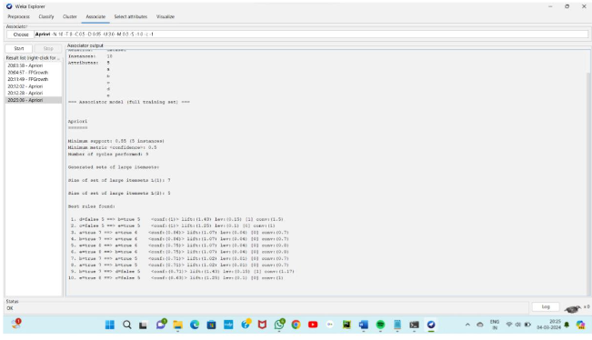

2.Consider the data set and perform the Apriori Algorithm and FP algorithm support:3 and confidence=50%

Consider the market basket transactions shown in the above table.

(a) What is the maximum number of association rules that can be extracted

from this data (including rules that have zero support)?

(b) What is the maximum size of frequent itemsets that can be extracted

(assuming minsup > 0)?

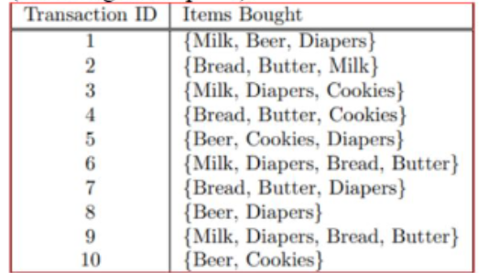

Input:

@relation dataset

@attribute milk{true,false}

@attribute beer{true,false}

@attribute diapers{true,false}

@attribute bread{true,false}

@attribute butter{true,false}

@attribute cookies{true,false}

@data

true true true false false false

true false false true true false

true false true false false true

false false false true true true

false true true false false true

true false true true true false

false false true true true false

false true true false false false

true false true true true false

false true false false false true

Ouput:

Appriori:

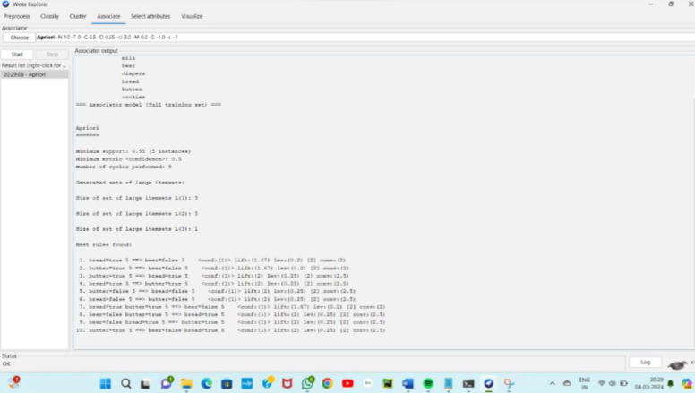

Fp-growth:

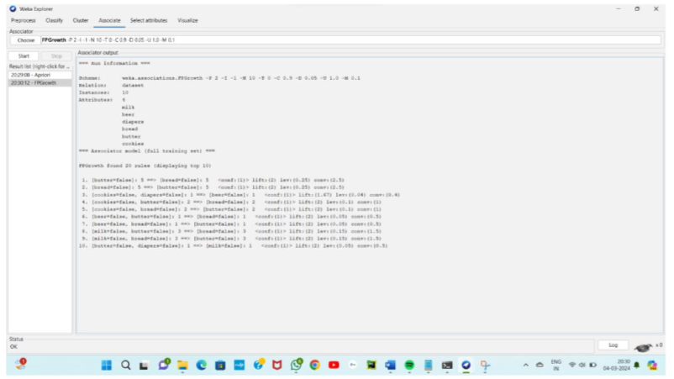

3.Bayes classification and descion tree (using training and test data)

Input: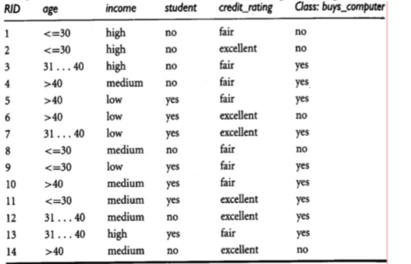

@relation decision_tree

@attribute age{young,middle,old}

@attribute income{low,medium,high}

@attribute student{yes,no}

@attribute creit_rating{fair,excellent}

@attribute class{yes,no}

@data

young high no fair no

young high no excellent no

middle high no fair yes

old medium no fair yes

old low yes fair yes

old low yes excellent no

middle low yes excellent yes

young medium no fair no

young low yes fair yes

old medium yes fair yes

young medium yes excellent yes

middle medium no excellent yes

middle high yes fair yes

old medium no excellent no

output:

decision tree:

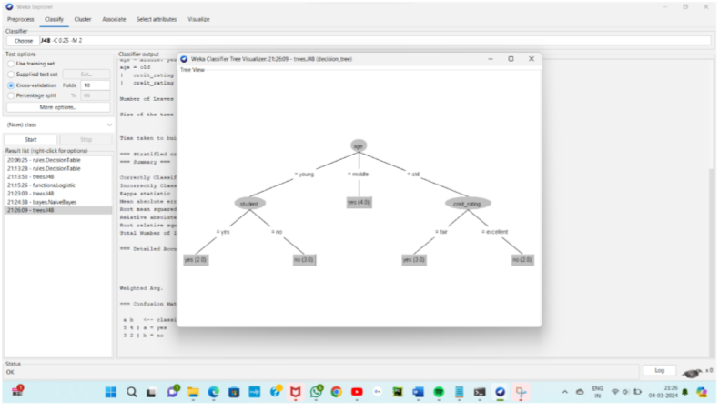

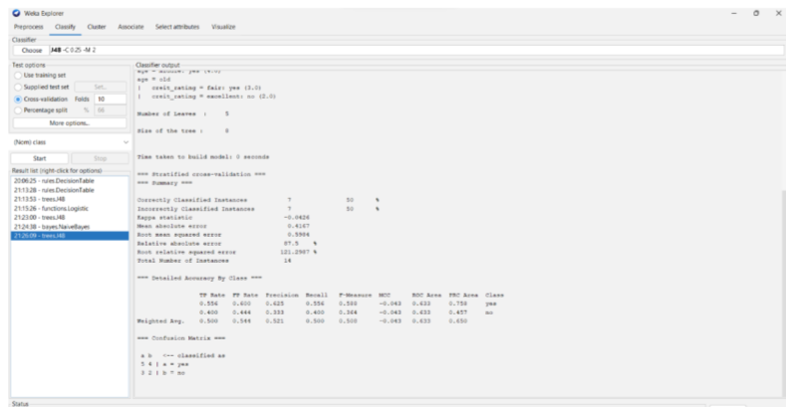

Naïve bayes:

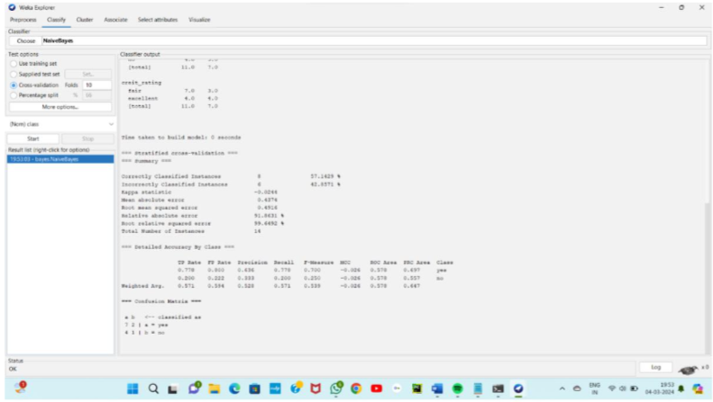

4.Analysis the dataset “diabetes. csv” how the diabetes trend is for different age people, using linear regression and multiple regression.

Output:

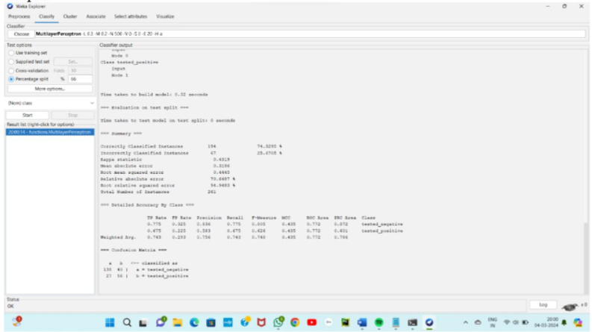

5.Implement using WEKA for the given Suppose a database has five transactions. Let min sup= 50%(2) and min con f = 80%.

Transactions Items

T1 (M, O, N, K, E, Y)

T2 (D, O, N, K, E, Y)

T3 (M, A, K, E)

T4 (M, U, C, K, Y)

T5 (C,O, O, K, I ,E)

• Find all frequent item sets using Apriori algorithm

• Also draw FP-Growth Tree

Input:

@relation dataset

@attribute M{true,false}

@attribute O{true,false}

@attribute N{true,false}

@attribute K{true,false}

@attribute E{true,false}

@attribute Y{true,false}

@attribute D{true,false}

@attribute A{true,false}

@attribute U{true,false}

@attribute C{true,false}

@attribute I{true,false}

@data

true true true true true true false false false false false false

false true true true true true true false false false false false

true false false true true false false false true false false false

true false false true false true false false false true true false

false true false true true false false false false false true true

output:

appriori:

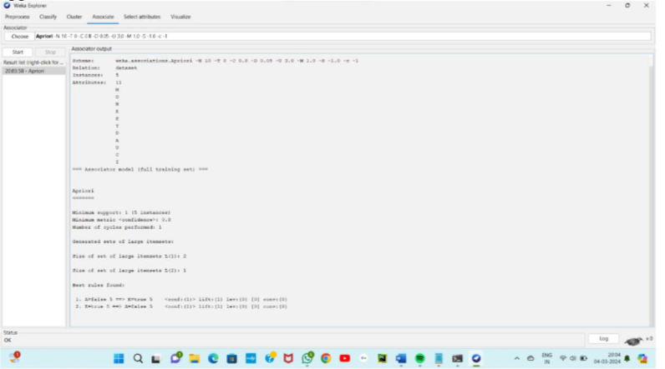

fpgrowth:

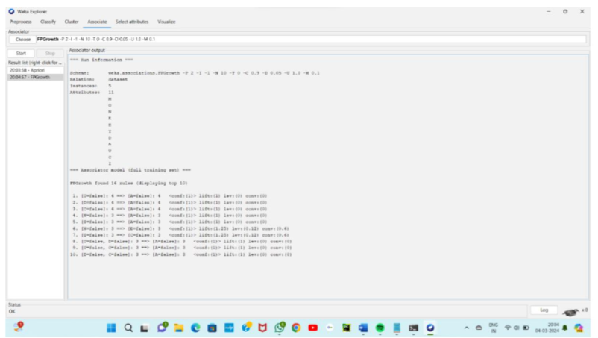

6. Prediction of Categorical Data using Decision Tree Algorithm through WEKA using any datasets. a) Tree b) Preprocess c) Logistic

Output:

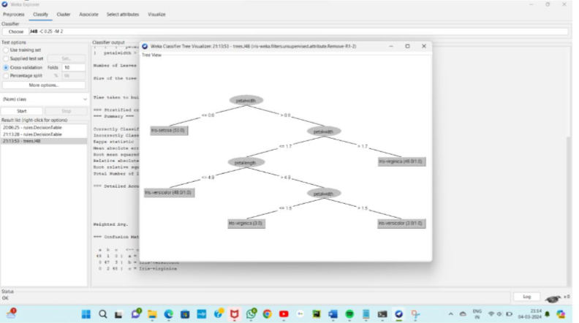

Logistic:

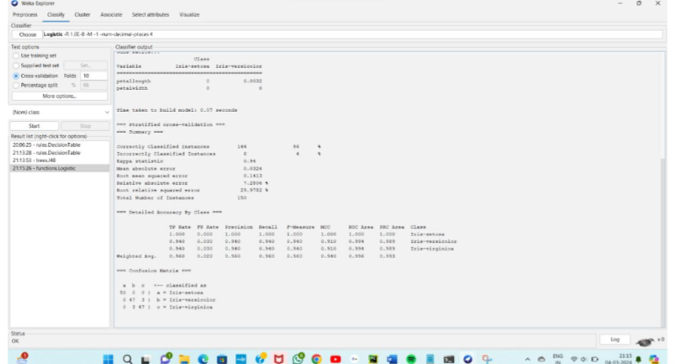

7.Create the dataset using ARFF file format:

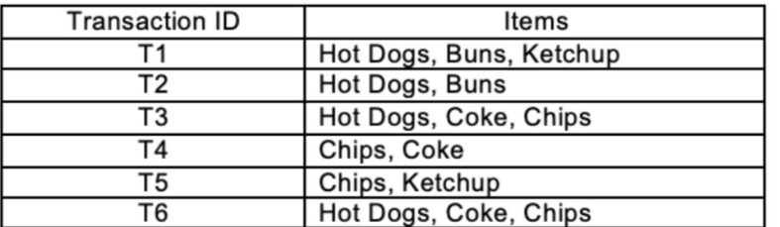

a.Find the frequent itemsets and generate association rules on this. Assume that minimum support threshold (s = 33.33%) and minimum confident threshold (c = 60%).

b.List the various rule generated by apriori and FP tree algorthim ,mention wheather accepted or rejected.

Input:

@relation dataset

@attribute hotdogs{true,false}

@attribute buns{true,false}

@attribute ketchup{true,false}

@attribute coke{true,false}

@attribute chips{true,false}

@data

true true true false false

true true false false false

true false false true true

false false false true true

false false true false true

true false false true true

**OUTPUT:**

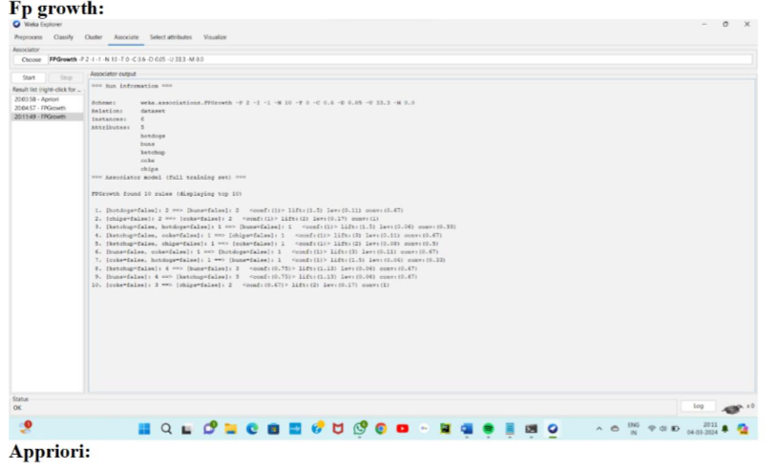

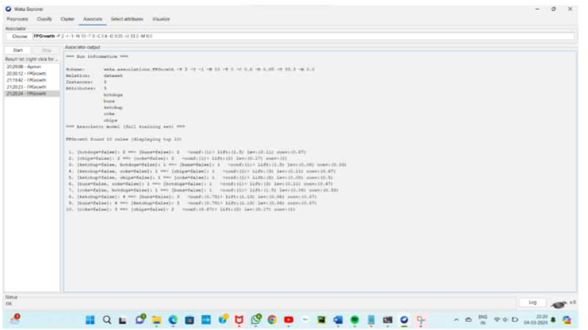

8.Prediction of Categorical Data using Rule base classification and decision tree classification through WEKA using any datasets. Compare the accuracy using two algorithm and plot the graph

output:

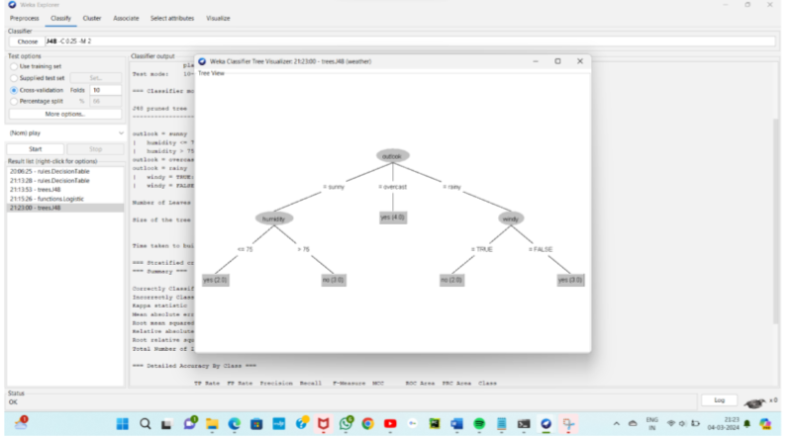

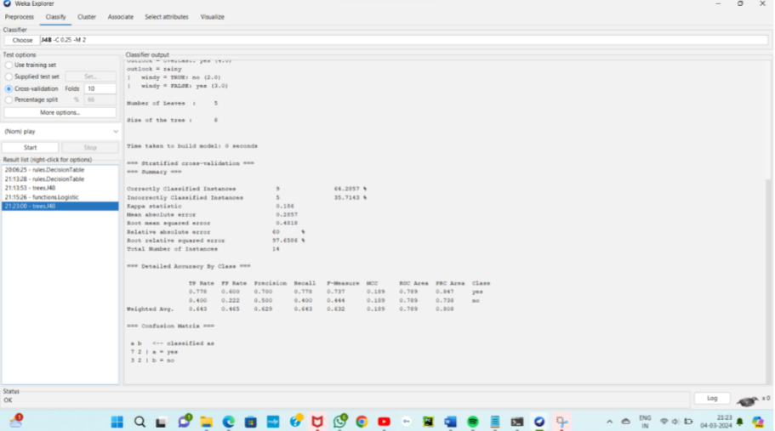

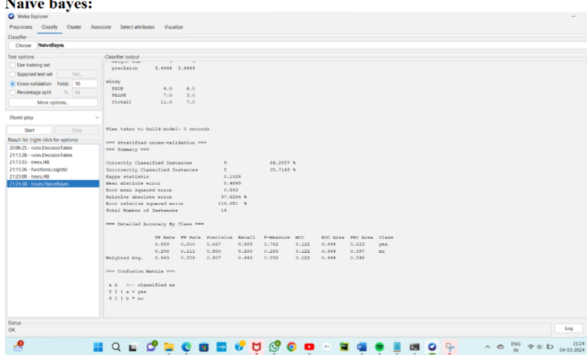

**DAY_4**

1.Consider that you are owning a supermarket mall and through membership cards, you have some basic data about your customers like Customer ID, age, gender, annual income and spending score. For the above scenario, the Problem Statement was You want to understand the customers who can easily converge [Target Customers] so that the data can be given to the marketing team and plan the strategy accordingly. For the above scenario prepare a dataset and perform Clustering Analysis to segment the customers in the Mall. There are clearly Five segments of Customers based on their Annual Income and Spending Score namely Usual Customers, Priority Customers, Senior Citizen Target Customers, and Young Target Customers.Sample data

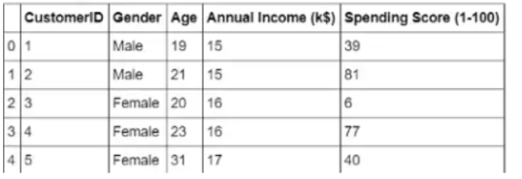

INPUT:

@relation dataset

@attribute customerid{1,2,3,4,5}

@attribute gender{male,female}

@attribute age{19,21,20,23,31}

@attribute annualincome{15,16,17}

@attribute spendingscore{39,81,6,77,40}

@data

1 male 19 15 39

2 male 21 15 81

3 female 20 16 6

4 female 23 16 77

5 female 31 17 40

Output:

K-MEANS:

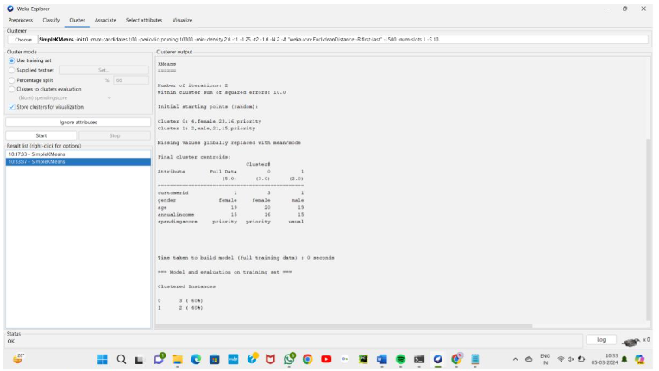

2.Create the following dataset using CSV file format. To perform cluster analysis using K- Means in WEKA. To change the cluster size and plot the graph and illustrate the visualization of cluster.

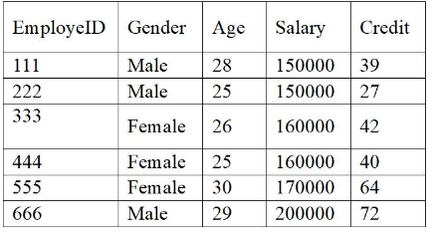

Input:

@relation dataset

@attribute id{1,2,3,4,5,6}

@attribute gender{male,female}

@attribute age{28,25,26,30,29}

@attribute salary{15,16,17,20}

@attribute credit{39,27,42,40,64,72}

@data

1 male 28 15 39

2 male 25 15 27

3 female 26 16 42

4 female 25 16 40

5 female 30 17 64

6 male 29 20 72

Output:

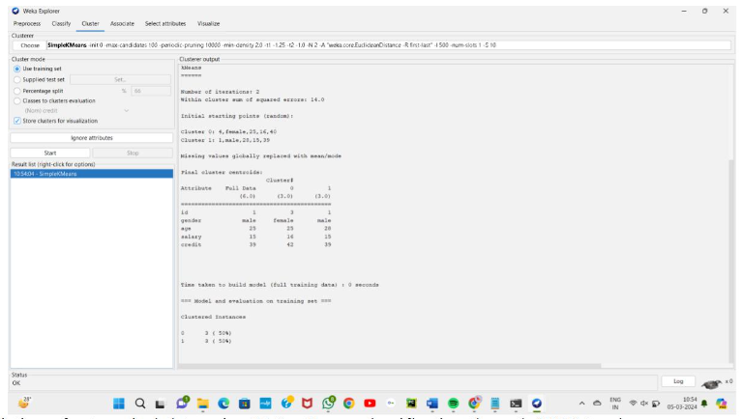

3.Prediction of categorical data using Naïve Bayes classification through WEKA using any datasets. Compare the Naïve Bayes algorithm with SVM using the summary of results given by the classifiers and plot the graph.

Output:

Naïve bayes:

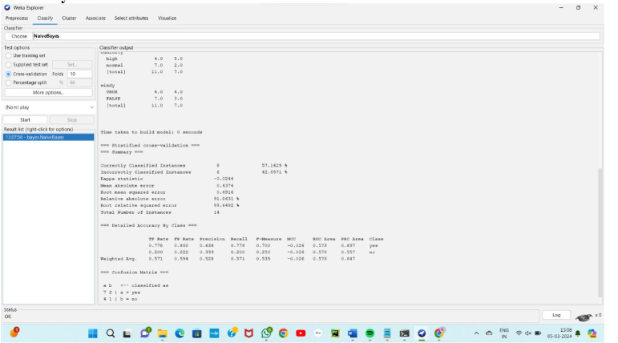

Svm:

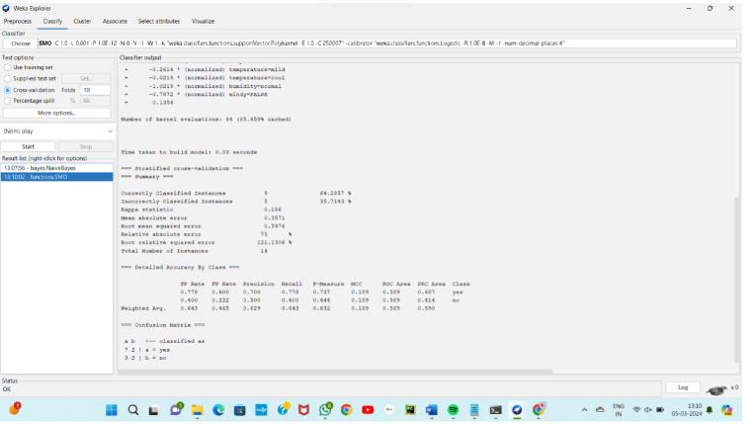

4.The following list of persons with vegetarian or not details given in the table. How will you find out how many of them are vegetarian and how many of them are non-vegetarian? Which type of the person total count is greater value?

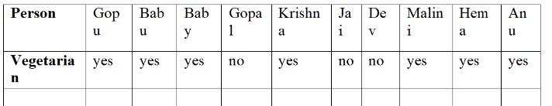

Input:

@relation dataset

@attribute person{gopu,babu,baby,gopal,krishna,jai,dev,malini,hema,anu}

@attribute vegeterian{yes,no}

@data

gopu yes

babu yes

baby yes

gopal no

krishna yes

jai no

dev no

malini yes

hema yes

anu yes

output:

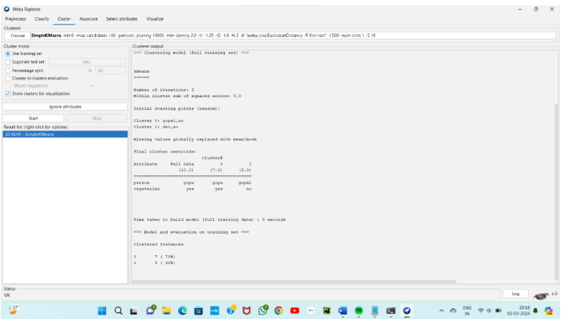

5.The following table would b plotted as (x,y) points, with the first column being the x values



as number of mobile phones sold and the second column being the y values as money. To use the scatter plot for how many mobile phones sold.

Input:

@relation dataset

@attribute x{4,1,5,7,10,2,50,25,90,36}

@attribute y{12,5,13,19,31,7,153,72,275,110}

@data

4,12

1,5

5,13

7,19

10,31

2,7

50,153

25,72

90,275

36,110

R programming:

x_values <- c(4, 1, 5, 7, 10, 2, 50, 25, 90, 36)

y_values <- c(12, 5, 13, 19, 31, 7, 153, 72, 275, 110)plot(x_values, y_values, main="Scatter Plot of Mobile Phones Sold",

xlab="Number of Mobile Phones Sold", ylab="Money",

pch=16, col="blue")

grid()

Output:

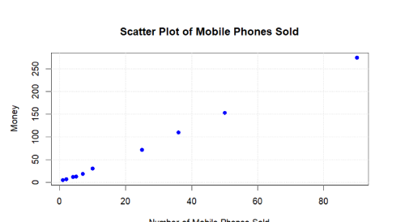

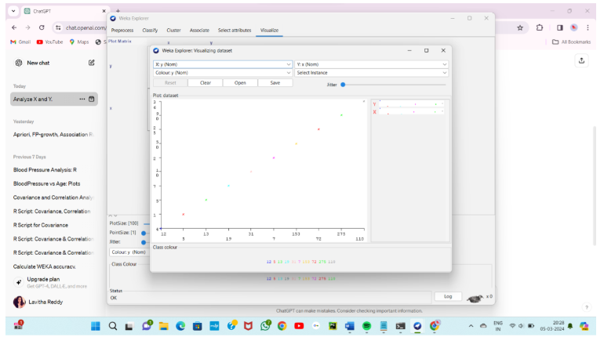

6.Generate rules using FP growth algorithm using the given dataset which has the following transactions with items purchased: Consider the values as support=50% and confidence=75%.

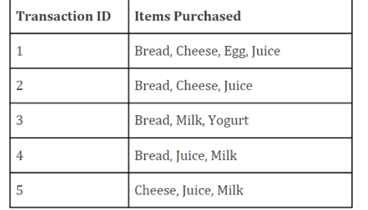

Input:

@relation dataset

@attribute transid{1,2,3,4,5}

@attribute bread{true,false}

@attribute cheese{true,false}

@attribute egg{true,false}

@attribute juice{true,false}

@attribute milk{true,false}

@attribute yogurt{true,false}

@data

1,true,true,true,true,false,false

2,true,true,false,true,false,false

3,true,false,false,false,true,true

4,true,false,false,true,true,false

5,false,true,false,true,true,false

Output:

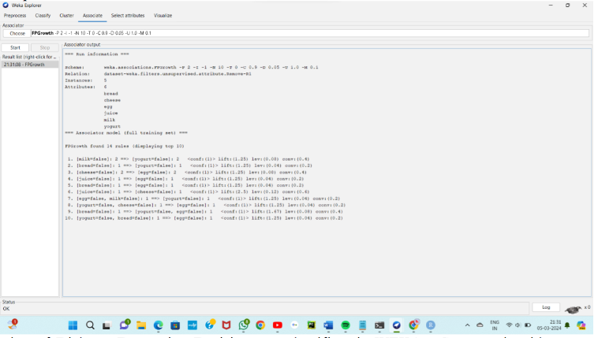

7.Prediction of Diabetes Data using Decision tree classifier in WEKA. Compare it with Support Vector Machine classifier. Show the result accuracy and F1 measure calculation .Plot the graph and explain the summary of results.

Output:

Naïve bayes

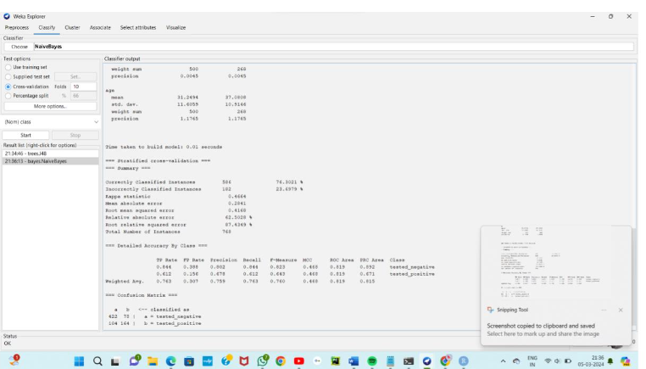

Decision tree:

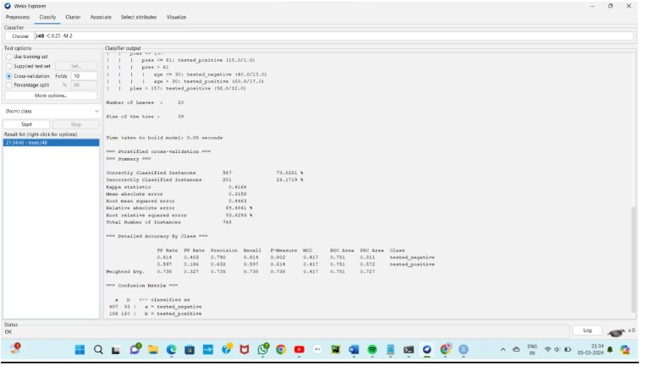

8. Implementing the R script using marks scored by a student in his model exam has been sorted as follows: 55, 60, 71, 63, 55, 65, 50, 55,58,59,61,63,65,67,71,72,75. Partition them into three bins by each of the following methods. Plot the data points using histogram.

(a) equal-frequency (equi-depth) partitioning

(b) equal-width partitioning

(c) clustering

Input:

marks <- c(55, 60, 71, 63, 55, 65, 50, 55, 58, 59, 61, 63, 65, 67, 71, 72, 75)

bins_a <- cut(marks, breaks = 3, labels = c("Low", "Medium", "High"))

bins_b <- cut(marks, breaks = seq(min(marks), max(marks), length.out = 4), labels = c("Low", "Medium", "High"))

k <- 3

clusters <- kmeans(matrix(marks), centers = k)

bins_c <- cut(clusters$centers[clusters$cluster], breaks = 3, labels = c("Low", "Medium", "High"))

par(mfrow = c(1, 3))

hist(marks, main = "Equal-frequency (equi-depth) partitioning", col = "skyblue", breaks = 3)

hist(marks, main = "Equal-width partitioning", col = "lightgreen", breaks = seq(min(marks), max(marks), length.out = 4))

hist(marks, main = "Clustering", col = "lightpink", breaks = 3)

output:

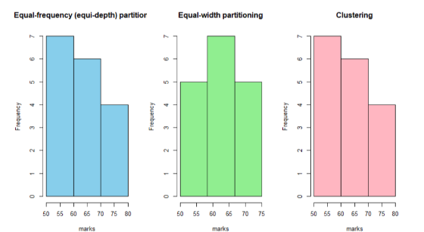

9.Consider this Decision tree :

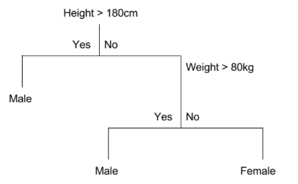

a)create the data set for the below tree using ARFF format and calculate accuracy and decision for the same

b) Using this decision tree generate the rules based on rule based induction.

c) Compare both the algorithms and plot the confusion matri

10.Create an ARFF file for the table below and implement for the Apriori Algorithm and FP growth algorithm and compare the rules generated by both the algorithms. Identify the unique rules generated by the above algorithms.

NOTE: Assume Min_sup=2 and confidence= 50%

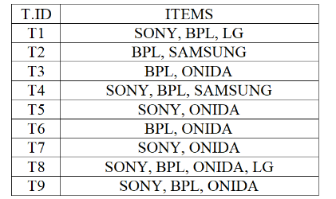

Input:

@relation dataset

@attribute id{1,2,3,4,5,6,7,8,9}

@attribute sony{true,false}

@attribute bpl{true,false}

@attribute lg{true,false}

@attribute samsung{true,false}

@attribute onida{true,false}

@data

1,true,true,true,false,false

2,false,true,false,true,false

3,false,true,false,false,true

4,true,true,false,true,false

5,true,false,false,false,true

6,false,true,false,false,true

7,true,false,false,false,true

8,true,true,true,false,true

9,true,true,false,false,true

Output:

Apriori:

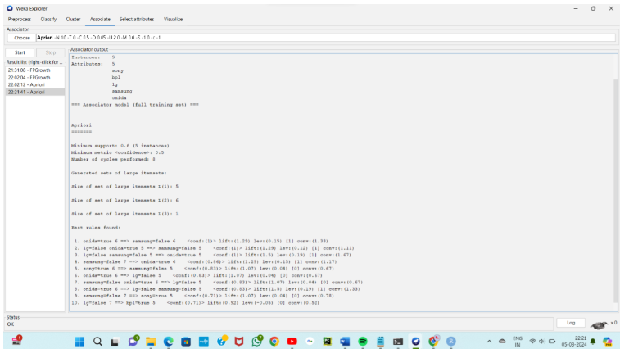

Fp-growth:

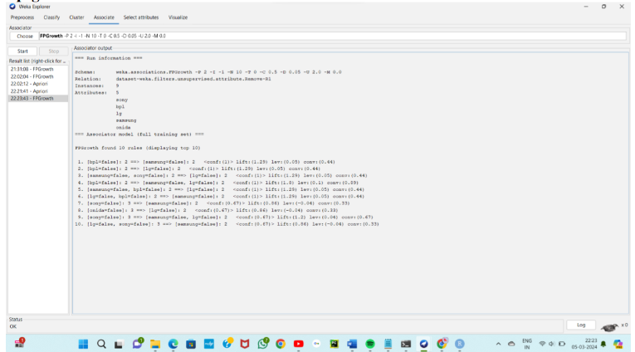

11,.The given are the strike-rates scored by a batsman in season 1 in different tournaments. 100, 70, 60, 90, 90

(a) min-max normalization by setting min = 0 and max = 1

(b) z-score normalization

(c) z-score normalization using the mean absolute deviation instead of standard deviation

(d) normalization by decimal scaling

input:

strike_rates <- c(100, 70, 60, 90, 90)

min_max_normalization <- function(x) {

(x - min(x)) / (max(x) - min(x))

}

normalized_min_max <- min_max_normalization(strike_rates)

z_score_normalization <- function(x) {

(x - mean(x)) / sd(x)

}

normalized_z_score <- z_score_normalization(strike_rates)

mad_normalization <- function(x) {

(x - mean(x)) / mad(x)

}

normalized_mad <- mad_normalization(strike_rates)

decimal_scaling_normalization <- function(x) {

x / 10^(ceiling(log10(max(x))))

}

normalized_decimal_scaling <- decimal_scaling_normalization(strike_rates)

cat("Original Data:", strike_rates, "\n\n")

cat("(a) Min-Max Normalization:", normalized_min_max, "\n")

cat("(b) Z-Score Normalization:", normalized_z_score, "\n")

cat("(c) Z-Score Normalization (MAD):", normalized_mad, "\n")

cat("(d) Normalization by Decimal Scaling:", normalized_decimal_scaling, "\n")

output:

> cat("(a) Min-Max Normalization:", normalized_min_max, "\n")

(a) Min-Max Normalization: 1 0.25 0 0.75 0.75

> cat("(b) Z-Score Normalization:", normalized_z_score, "\n")

(b) Z-Score Normalization: 1.095445 -0.7302967 -1.338877 0.4868645 0.4868645

> cat("(c) Z-Score Normalization (MAD):", normalized_mad, "\n")

(c) Z-Score Normalization (MAD): 1.214083 -0.8093889 -1.48388 0.5395926 0.5395926

> cat("(d) Normalization by Decimal Scaling:", normalized_decimal_scaling, "\n")

(d) Normalization by Decimal Scaling: 1 0.7 0.6 0.9 0.9

12.Suppose some car is tested for the AvgSpeed and TotalTime data for 9 randomly selected car with the following result

a) Calculate the standard deviation of AvgSpeed and TotalTime.

b) Calculate the Variance of AvgSpeed and TotalTime for the above dataset.

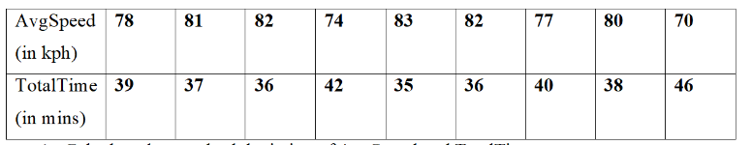

Input:

avg_speed <- c(78, 81, 82, 74, 83, 82, 77, 80, 70)

total_time <- c(39, 37, 36, 42, 35, 36, 40, 38, 46)

sd_avg_speed <- sd(avg_speed)

sd_total_time <- sd(total_time)

var_avg_speed <- var(avg_speed)

var_total_time <- var(total_time)

cat("Standard Deviation of AvgSpeed:", sd_avg_speed, "\n")

cat("Standard Deviation of TotalTime:", sd_total_time, "\n\n")

cat("Variance of AvgSpeed:", var_avg_speed, "\n")

cat("Variance of TotalTime:", var_total_time, "\n")

output:

var_avg_speed <- var(avg_speed) > var_total_time <- var(total_time) > cat("Standard Deviation of AvgSpeed:", sd_avg_speed, "\n") Standard Deviation of AvgSpeed: 4.304391 > cat("Standard Deviation of TotalTime:", sd_total_time, "\n\n") Standard Deviation of TotalTime: 3.492054 > > cat("Variance of AvgSpeed:", var_avg_speed, "\n") Variance of AvgSpeed: 18.52778 > cat("Variance of TotalTime:", var_total_time, "\n") Variance of TotalTime: 12.19444

13.Consider this table

c) TID items bought

d) T100 {M, O, N, K, E, Y}

e) T200 {D, O, N, K, E, Y }

f) T300 {M, A, K, E}

g) T400 {M, U, C, K, Y}

h) T500 {C, O, O, K, I ,E}

i) (a) Find all frequent item set using Apriori and FP-growth, respectively. Compare the efficiency of the two mining processes.

j) (b) List all of the strong association rules (with support s and confidence c) matching the following metarule, where X is a variable representing customers, and itemi denotes variables representing items (e.g., “A”, “B”, etc.):

k) ∀x ∈ transaction, buys(X, item1) ∧ buys(X, item2) ⇒ buys(X, item3)

Input:

@relation dataset

@attribute M{true,false}

@attribute O{true,false}

@attribute N{true,false}

@attribute K{true,false}

@attribute E{true,false}

@attribute Y{true,false}

@attribute D{true,false}

@attribute A{true,false}

@attribute U{true,false}

@attribute C{true,false}

@attribute I{true,false}

@data

true true true true true true false false false false false false

false true true true true true true false false false false false

true false false true true false false false true false false false

true false false true false true false false false true true false

false true false true true false false false false false true true

